Cherry Blossom  Ingredients:  crab stick, light cream cheese, sushi rice, lettuce, tempura, green onion, spicy mayo, rice paper. | 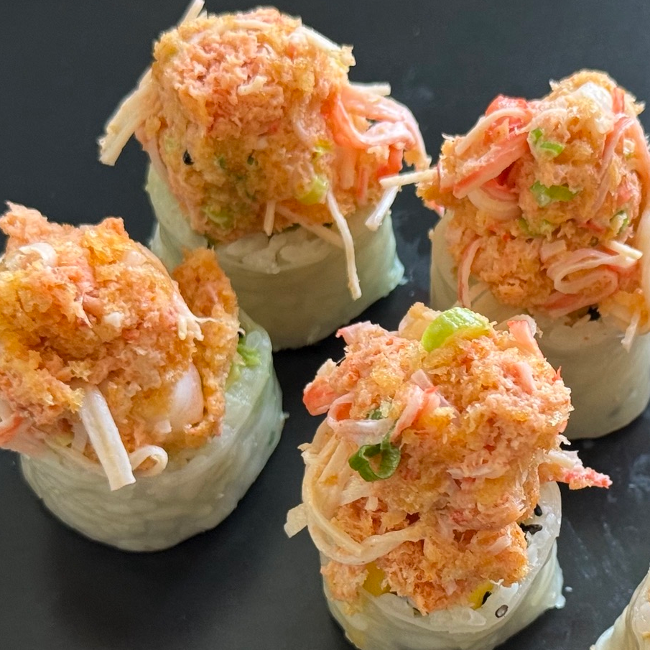

Cherry Blossom
Ingredients:
crab stick, light cream cheese, sushi rice, lettuce, tempura, green onion, spicy mayo, rice paper.

Cherry Blossom
Ingredients:
crab stick, light cream cheese, sushi rice, lettuce, tempura, green onion, spicy mayo, rice paper.

Cherry Blossom
Ingredients:
crab stick, light cream cheese, sushi rice, lettuce, tempura, green onion, spicy mayo, rice paper.

